

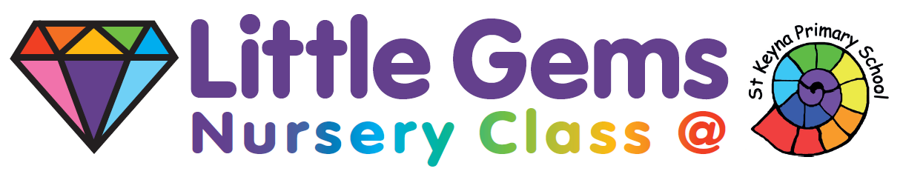
NEW ENQUIRIES FORM

PARENTS’/CARERS’ NAMES | CURRENT ADDRESS
TEL. NUMBER & email address | NEW ADDRESS IN KEYNSHAM (if known)
CHILD/REN’S NAME/S | DATE/S OF BIRTH  .

DATE WISHING TO START

ADDITIONAL INFORMATION

